**AIM: Equivalent Resistance of Series, Parallel and Series Parallel Circuits**

**Apparatus:**

1. Resistors
2. Multi-meter
3. Jumper Wires
4. Breadboard
5. DC Supply

**Objectives:**

1. Strengthening of concepts of
   1. Series
   2. Parallel and
   3. Series-parallel
   4. Equivalent resistances
2. Circuit construction on breadboard
3. Importance of **“Viewpoint”** while calculating equivalent resistance

**Pre-Lab:**

1. Two resistors are said to be in series if joining of the two forms a node. The total (often referred to as “Equivalent Resistance”, abbreviated as Req) in this case is the simple sum of the individual resistance. Current in series-connected elements is the same (a direct derivation from KCL). Also, equivalent resistance is equal to the voltage applied across the combination divided by the current flowing through it (R = V / I).
2. Two or more resistors are said to be in parallel, if joining them forms a node pair. The reciprocal of equivalent resistance is the sum of reciprocals of the resistors connected in parallel. Voltage across parallel-connected elements is the same. Also, equivalent resistance is equal to the voltage applied across the combination divided by the current flowing through it (R = V / I).
3. For two resistors in parallel, the equivalent resistance is equal to the product of the two resistor values divided by their sum.
4. Viewpoint is the pair of access points to the circuit, where the multi-meter probes are connected to the circuit. All theoretical calculations have to be made keeping in view the selected set of points.

**Procedure:**

**a) Series Circuit:**

1. Take three resistors and note their values after confirmation by color code and multimeter measurements.
2. Construct a series circuit of these resistors as shown below.

A B

R1 R2 R 3

1. Calculate the equivalent resistance using formula.
2. Check the resistance of the series combination by connecting the multimeter probes at points A and

B.

1. Connect a measured voltage between points A and B and note the current flowing through the circuit (For this the multimeter has to be connected in series with the circuit, with selector pointed at mA and black probe plugged into mA socket of the meter). The total resistance is calculated using the relationship **R = V / I**. The circuit diagram is depicted below:

R

1

R

2

R

3

A

B

A

**b) Parallel Circuit:**

1. Repeat step a) 1.
2. Construct a parallel circuit of these resistors as shown below:

R

2

R

1

R

3

A

B

1. Calculate the equivalent resistance using formula
2. Check the resistance of the parallel combination by connecting the multimeter probes at A and B.
3. Connect a measured voltage between points A and B and note the current flowing through the circuit (For this the multimeter has to be connected in series with this parallel circuit, with selector pointed at mA and black probe plugged into mA socket of the meter). The total resistance is calculated using the relationship **R = V / I**. The circuit

diagram is depicted below:

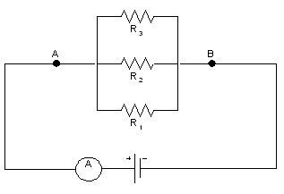

**c) Series Parallel Circuit:**

1. Repeat step a) 1.
2. Construct a series parallel circuit of these resistors as shown below:

R

2

R

1

R

3

A

B

1. Calculate the equivalent resistance using formula.
2. Check the resistance of the series parallel combination by connecting the multimeter probes at A and B.
3. Connect a measured voltage between points A and B and note the current flowing through the circuit (For this the multimeter has to be connected in series with this series-parallel circuit, with selector pointed at mA and black probe plugged into mA socket of the meter). The total resistance is calculated using the relationship **R = V / I**. The circuit diagram is depicted below:

R

2

R

1

R

3

A

A

B

**d) View point:**

1. Repeat step a) 1.
2. Construct a circuit of these resistors as shown below:

R

2

R

1

R

3

A

C

B

1. Calculate the resistance between points AB, BC and AC using theoretical concepts.
2. Check the resistance of the circuit by connecting the multimeter probes at A and B, then at B and C and then at A and C.
3. Connect a measured voltage between points A and B and note the current flowing through the circuit.

The total resistance is calculated u

sing

the relationship

**R = V / I**

.

The

different

circuit

configurations are depicted

below:

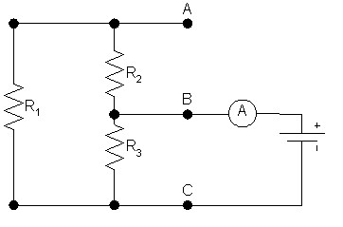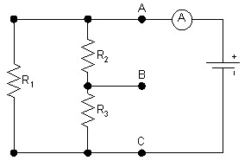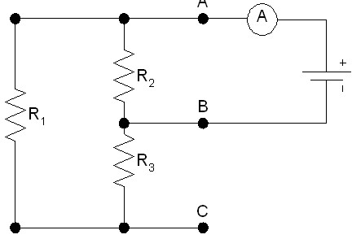

**Observations and Calculations:**

1. **Series Circuit:** 
   * Equivalent resistance using formula:

* + Resistance of the series combination measured by multimeter:

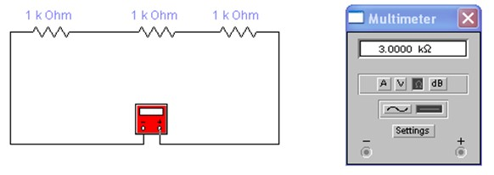

* + Current flowing through the circuit measured by multimeter:

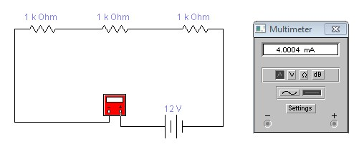

* + Total resistance of the circuit measured by multimeter:

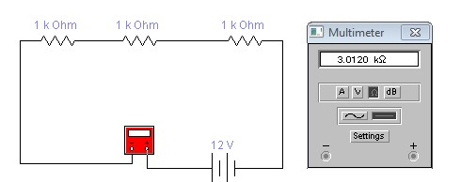

* + Calculation of the total resistance of the circuit:

|  |  |  |  |  |  |  |  |
| --- | --- | --- | --- | --- | --- | --- | --- |
| **Resistor symbol** | | **Value (****)** | |  |  | **Value to be used in calculation (****)** | |
|  | | **Multi meter** | |  |  |  | |
| **R1** | |  | |  |  |  | |
| **R2** | |  | |  |  |  | |
| **R3** | |  | |  |  |  | |
|  |  |  | |  |  |  |  |
| **S.**  **No.** | **Total Resistance Value (****)** | | | **Applied Voltage**  **(V)** | | **Current**  **(A)** | **Resistance value (V/I)**  **(****)** |
| **Calculated using formula** | | **Measured with multimeter** |
|  |  | |  |  | |  |  |

1. **Parallel Circuit:** 
   * Equivalent resistance using formula:

* + Resistance of the parallel combination measured by multimeter:

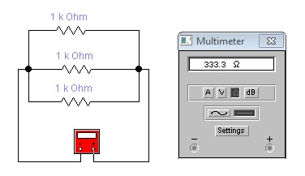

* + Current flowing through the circuit measured by multimeter:

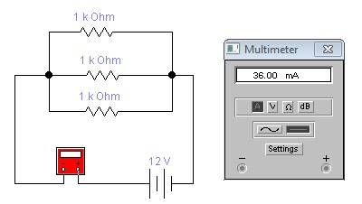

* + Total resistance of the circuit by multimeter:

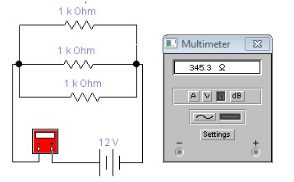

* + Calculation of the total resistance of the circuit:

|  |  |  |  |  |  |  |  |
| --- | --- | --- | --- | --- | --- | --- | --- |
| **Resistor symbol** | | **Value (****)** | | | **Value to be used in calculation (****)** | | |
|  | | **Multi meter** | | |  | | |
| **R1** | |  | | |  | | |
| **R2** | |  | | |  | | |
| **R3** | |  | | |  | | |
| **S.**  **No.** | | **Total Resistance Value (****)** | | | **Applied Voltage**  **(V)** | | **Current**  **(A)** | **Resistance value (V/I)**  **(****)** | |
| **Calculated using formula** | | **Measured with multimeter** |
|  | |  | |  |  | |  |  | |

1. **Series Parallel Circuit:** 
   * Equivalent resistance using formula:

* + Resistance of the series parallel combination measured by multimeter:

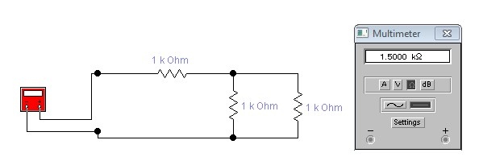

* + Current flowing through the circuit measured by multimeter:

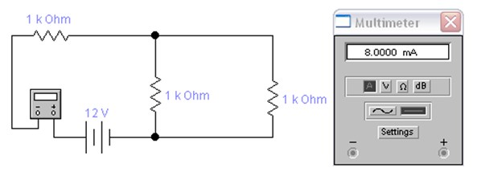

* + Total resistance of the circuit by multimeter:

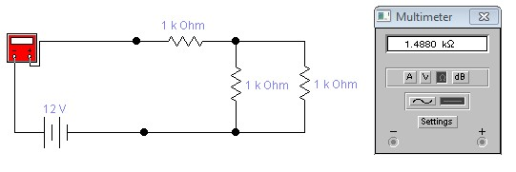

* + Calculation of the total resistance of the circuit:

|  |  |  |
| --- | --- | --- |
| **Resistor symbol** | **Value (****)** | **Value to be used in calculation (****)** |
|  | **Multi meter** |  |
| **R1** |  |  |
| **R2** |  |  |
| **R3** |  |  |

|  |  |  |  |  |  |
| --- | --- | --- | --- | --- | --- |
| **S.**  **No.** | **Total Resistance Value (****)** | | **Applied Voltage**  **(V)** | **Current**  **(A)** | **Resistance value (V/I)**  **(****)** |
| **Calculated using formula** | **Measured with multimeter** |
|  |  |  |  |  |  |

|  |  |  |
| --- | --- | --- |
| **Resistor symbol** | **Value (****)** | **Value to be used in calculation (****)** |
|  | **Multi meter** |  |
| **R1** |  |  |
| **R2** |  |  |
| **R3** |  |  |

# d)

**View point:**

* Calculate the resistance between points AB, BC and AC:

* 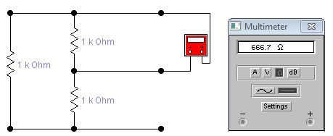Resistance of the circuit: **At AB:**

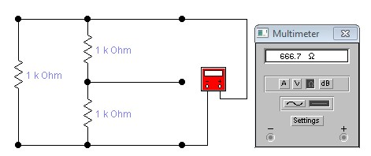

**At AC:**

**At BC:**

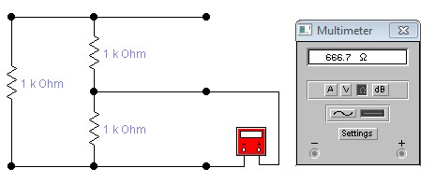

* Current flowing through the circuit measured by multimeter:

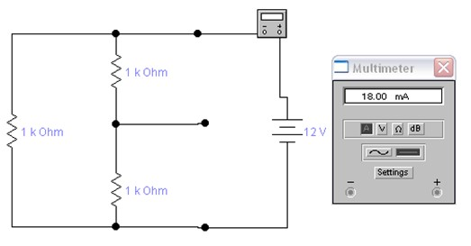

* Calculation of the total resistance of the circuit:

|  |  |  |  |  |  |
| --- | --- | --- | --- | --- | --- |
| **S.**  **No.** | **Total Resistance Value (****)** | | **Applied Voltage**  **(V)** | **Current**  **(A)** | **Resistance value (V/I)**  **(****)** |
| **Calculated using formula** | **Measured with multimeter** |
| AB |  |  |  |  |  |
| BC |  |  |  |  |  |
| CD |  |  |  |  |  |

|  |  |  |
| --- | --- | --- |
| **Resistor symbol** | **Value (****)** | **Value to be used in calculation (****)** |
|  | **Multi meter** |  |
| **R1** |  |  |
| **R2** |  |  |
| **R3** |  |  |